UKS2 What does the Qur’an reveal about Allah and his guidance?
What should we know?
Revelation is how Allah imparts whatever he wishes to those he chooses.
Muslims believe:
- The greatest revelation has come from Allah to the Prophet Muhammad and is recorded in the Qur’an.
- The Qur’an reveals what God is like, provides guidance for living and the key to preparation for the life to come.
- The words of the Qur’an are the actual words of Allah received over a period of time by the Prophet Muhammad through the Angel Jibreel (Gabriel).

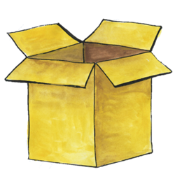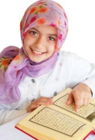

Prior
learning
That Allah is the one true God – compassionate and merciful. He should be obeyed in every way.
Muhammad – revered but not to be worshipped - was chosen by Allah to be his final prophet.
Muhammad told people to submit to Allah and to worship no-one else.

What should we be able to do?
Explain how Muslims show respect for the Qur’an.
Retell the story of how the Qur’an was revealed to Muhammad.
Describe some practices and experiences of Muslim children at a madrassah.
Describe why only some Muslims seek to become Hafiz and how the study affects both their lives and the lives of others.
Show how Muslims express the idea of revelation as a rope reaching down to earth, suggesting what the image means.
Make links that show how Muslim belief and practices come from the teachings of the Qur’an or from the Sunnah of the Prophet.
Prayer beads – reminder of Allah’s 99 names.

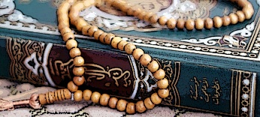
Muslim children learn to recite the Qur’an in Arabic.
The Qur’an – the final revelation from Allah.
What words should we understand and be able to use?
Revelation | How Allah makes himself known to Earth. | Cave Hira | Where Muhammad received the Qur’an.
Madrassah | A Muslim school (often part of the Mosque). Children learn to recite the Qur’an here often two hours after school and on a Saturday. | Hafiz | Someone who has memorised the Qur’an off by heart.

