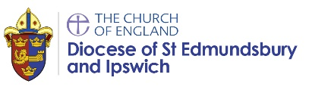
Year group: Term: Date: Class:

Why do Jewish families say so many prayers and blessings?
Teachers will enable pupils to be able to achieve some of these outcomes, as appropriate to their age and stage:
Working towards: | Expected: | Greater depth:
Pupils will be able to recall that Jewish people say prayers and rest, but need prompting to give examples of when and how. | Pupils working at an expected level will recognise a Jewish sukkah and describe some of the ways it is decorated and used. They will understand that saying blessings and thank you to God is important to Jewish people and they can give examples of when blessings are made e.g. at mealtimes and shabbat. They can extend their knowledge to talking about the importance of rest, linking this to the story of creation.  Ultimately, pupils understand the key idea from this unit:  Jewish people give thanks to God and learn about the importance of rest through listening to the creation story. | These pupils describe practices such as the purpose of the sukkah – linking it to the stories from the past and a means to give thanks to God, and can describe what happens at shabbat. They use the correct terminology – blessings, prayers, shabbat etc. They understand Jewish worship at home and at the synagogue.
Names  <when assessed, list names of children in class here> | Names  <when assessed, list names of children in class here> | Names  <when assessed, list names of children in class here>
% | % | %

