UKS2 What is the great significance of the ‘Eucharist’ to Christians?
What should we know?
The Eucharist is when Christians give thanks for bread and wine in memory of Jesus. It is a central act of worship.
Christians believe:
- It is important to give thanks to God. It is a Christian duty.
- During the Lord’s Supper, the Passover feast with his disciples on the evening before he was betrayed, Jesus commanded his followers to remember him.
- The Eucharist is a reminder of Jesus’ sacrifice on their behalf but also of things which should make them glad: of God’s amazing love and forgiveness.

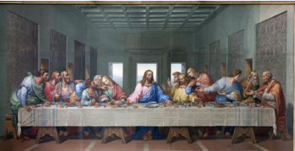

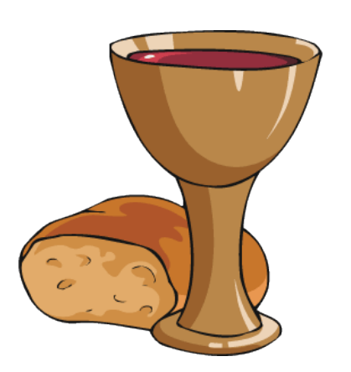
Prior learning: Christians are followers of Jesus, the saviour of the world. He died but came back to life. This is good news.
A cross reminds Christians of his sacrifice, but is also a sign of commitment and God’s love.
In the Gospel, Jesus told parables to teach about God’s Kingdom and the right way to live. Christians serve others as a response to being saved.
God offers us forgiveness.
The Holy Spirit reminds Christians God is always with them. He gives them strength.

What should we be able to do?
Explain that the last Passover feast Jesus shared with his disciples is known as the Lord’s Supper.
Describe what happens at an Anglican communion service.
Describe what the Eucharist means to Christians today – how it reminds them to be thankful.

The Last Supper.

T
Thgehe
The Eucharist reminds Christians to give thanks daily.

What words should we understand and be able to use?
Eucharist | Giving thanks with bread and wine in memory of Jesus. | Holy Communion | Another name for the Eucharist.
Passover feast | Passover is a celebration of the story of Exodus. During Passover, Jews remember how their ancestors left slavery behind them when they were led out of Egypt by Moses. Passover is celebrated with a feast.

