**LKS2 How does a Muslim show their submission and obedience to Allah?**

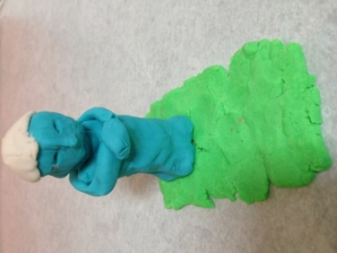

**

**What should we know?**

That **submission** is about recognising that Allah is to be obeyed at all times.

That Muslims believe:

* That Allah is the one true God; the most important being in the universe.
* That Allah should be obeyed in every way and Muslims trust him to tell them the right thing to do.
* That praying five times a day helps them to remember to submit to Allah in all they do.

**Prior**

**learning**

The importance of the names ‘Allah’ and ‘Muhammad’ to Muslims.

Stories about Muhammad.

The different names of Allah e.g. the doer of good, the generous, which show what a Muslim believes about God.

**What should we be able to do?**

*Explain how a Muslim responds when hearing the Adhan.*

*Explain that Muslim means ‘one who ‘submits’ or who willingly does what God wants them to do.*

*Explain a Muslim learns from the story of Bilal and the first call to prayer to submit to Allah.*

*Describe some things Muslims do when they get ready for prayer and how the physical actions show submission to Allah.*

*Understand that saying the Bismillah reminds Muslims that Allah is involved in everything.*

Praying five times a day

Prayer mat

Whispering the call to prayer

**What words should we understand and be able to use?**

|  |  |  |  |
| --- | --- | --- | --- |
| **Submission** | For a Muslim this means obeying Allah as creator of all. | **Adhan** | The Adhan is the Muslim call to prayer performed in Arabic. It announces the beginning of a set period of prayer. |
| **Bismillah** | This means ‘in the name of Allah.’ The first words in their holy book. Muslims says this before starting anything. | **Muezzin**  (mu’adhin) | One who calls the adhan, five times a day, by a muezzin from the top of a minaret (tower on the mosque). |
| **Salat** | The ritual prayer of Muslims, performed five times daily in a set form. | **Muslim** | A follower of Islam. One who submits to Allah. |